Attendant Travel Expenses Reimbursement

The finance department of a popular manufacturing unit is into automating their business processes. One of their modules is the automation of Travel Expenses Reimbursement. The department gets numerous reimbursement requests and processing them manually takes enormous time. Help them with the automation of the same by developing a web page to calculate the total reimbursed amount, along with the accommodation cost, dining cost, local travel cost and allowances. On submitting the necessary details, the message on reimbursement amount has to be displayed in the same page as shown in the given screenshots.

Plain Web page design :
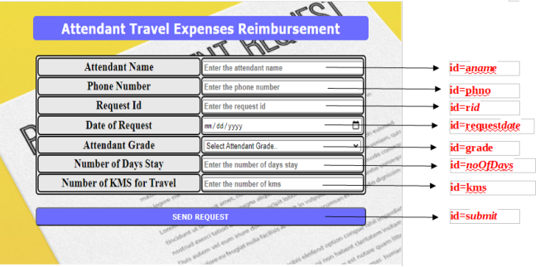
Web page after entering all valid details and clicking on SEND REQUEST button :
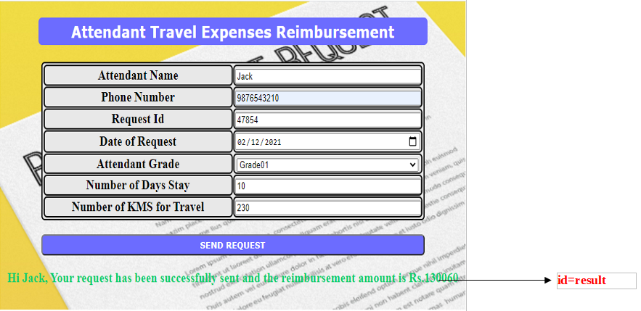
Use the Label Name and the Component Id as given. All the necessary attributes for the Components should be given. The Component Id should be specified for each HTML Component. If the Component Id is not provided for an HTML component, marks will not be provided for that component. All Tags, Elements and Attributes should conform to HTML5 Standards. All the fields are mandatory.
Provide the details as given in the table below:
Req. # | Req. Name | Req. Description
1 | Design an HTML page for “Attendant Travel Expenses Reimbursement” | Note: The text highlighted in bold in the Description needs to be implemented in the code to complete the web page design.
  Label Name | Component Id  (Specify it for the “id” attribute) | Description
  Attendant Name | aname | To enter the name of the employee.  Design Constraints:  - The text “Enter the attendant name” should appear by default.  - It should be mandatory.  - Use type=“text”
  Phone Number | phno | To enter the phone number of the employee.  Design Constraints:  - The text “Enter the phone number” should appear by default.  - It should be mandatory.  - Use type=“text”
  Request Id | rid | To enter the request id.  Design Constraints:  - The text “Enter the request id” should appear by default.  - It should be mandatory.  - Use type=“text”
  Date of Request | requestdate | To enter the request date.  Design Constraints:  - Use type=“date”  - It should be mandatory.
  Attendant Grade | grade | To select the employee grade.  Design Constraints  Use the drop down box with “Select Attendant Grade..”, “Grade01”, ”Grade02”, “Grade03” as the options.  The field is mandatory.
  Number of Days Stay | noOfDays | To enter the number of days of stay.  Design Constraints:  - The text “Enter the number of days stay” should appear by default.  - It should be mandatory.  - Use type=“text”
  Number of KMS for Travel | kms | To enter the number of kms.  Design Constraints:  - The text “Enter the number of kms” should appear by default.  - It should be mandatory.  - Use type=“text”
   | submit | Submit Button to submit the form  Design Constraints  - The input type should be “submit”.  - The value should be "SEND REQUEST"
2 | Apply the mentioned styles using CSS to the components | STYLING WITH ELEMENT SELECTORS  - HEADING should be specified using <h3> tag.  Its color must be #FFFFFF and the background-color must be #6666FF.  The margins: margin-left and margin-right must be auto.  The text-align must be center and width 50%.  The font-family of the text must be Verdana.  The padding and border-radius must be 5px and 6px respectively.  - TABLE, tr and td must be styled with width as 50% .  The margins: margin-left and margin-right must be auto.  The border-spacing and border-radius must be 1px and 6px respectively.  Its color must be #000000 and the background-color must be #E6E6E6.  The padding must be 1px.  STYLING WITH ID SELECTOR  SUBMIT component must be styled using its id as in :  Its color must be #FFFFFF and the background-color must be #6666FF.  The margins: margin-left and margin-right must be auto.  The padding must be 5px and width must be 50%.  The font-family of the text must be Verdana and font-weight must be bold.  The border-radius must be 6px.  RESULT component must be styled using its id as in:  Its color must be #00CC66 and the font-size must be 20px.  Note: Fill in the style tag so as to have the given styles applied to the components. (Do not use Inline CSS)
3 | Use JavaScript for displaying the reimbursed amount details. | Use JavaScript for displaying the reimbursed amount details:  When the valid values are entered and the “Submit” button is clicked, the reimbursed amount should be displayed as follows:  “Hi employeeName, your request has been successfully sent and the reimbursement amount is Rs. reimbursedAmount ”  in a div tag with id as “result”.  Formula:  accommodationCost = accommodationCost/day*noOfDays  dinningCost = dinningCost/day*noOfDays  localTravelCost = localTravelCost/km*kms  allowances = allowances/day*noOfDays  totalReimbursementAmount=accommodationCost+diningCost+localTravelCost+allowances  Example: If the number of days of stay is 5 for grade01 and total travel kms (local) is 150, then  Accommodation cost = Rs. 50000  Dining cost = Rs. 5000  Local travel cost = Rs. 3300  Allowances = Rs. 7500  Total Reimbursement amount = Rs. 65800  Note:  - Use the getElementById() function to retrieve the values.  - In Javascript, Please do not use “let” or “const”. Instead, use “var”.
  EmployeeGrade | Accommodation Cost/Day | Dining Cost/Day | Local Travel Cost/km | Allowances/Day
  Grade01 (Highest) | 10000 | 1000 | 22 | 1500
  Grade02 | 10000 | 1000 | 22 | 1500
  Grade03 | 4000 | 700 | 16 | 1000
4 | form Tag with attribute onsubmit | form Tag is already given in the code template. Do not change the code template and do the coding as per the requirements and specification.  Make sure that the onsubmit attribute in the form tag invokes the JavaScript function like "return display()". Also ensure that the “return false;” statement should be the last line of the JavaScript function “display()”.

